9.3

Last week lost money mainly on direction.

Intraday MA/perc MA additions were losing money.

Goal this week

1. Make sure directional trades are in place.
2. Less frequency. (Don’t do high freq unless at open. 5 min is enough)
3. Trade no more than 6 per strategy.
4. Make money on highly directional days, don't lose too much on directionless days. Didn’t make money on last Monday (up directional) because size was small, size was small because waittime was too short. Elongate waittime -> bigger size.
5. Trade same strategy for both cash and futs, see which one is more effective.
6. Now directional trades: openDev, futHilo, indexHilo.
7. Profit taking trades: MA, indexMA, percMA.
8. Stock trading cost too much $, cut all pos. Focus on auto trading.

Fut trading essentials

1. Bottom line is 20dma to determine direction, default delta.
2. Better than stocks because you can only be long -> trading stocks will cause you to lose money due to, trading cost (10 bps selling + 1.5 bps). Futures cost you 1.5 bps. Per year that 10 bp is already 28%. Long term stock investing: no confidence in the economy (technology too backwards, not enough good companies. Good companies don’t want to be listed because they think the investors are not worthy, )

Index more stable for MA, less price manipulations

Fut more suitable for hilo, hard to manipulate hilo, but easier to manipulate other levels.

End of day:

Trading pnl  
china Hilo: Total -2, pnl: -18

PM_HILO, total -1, pnl -46.5

Buying orders were stopped by nomorebuy Boolean, delta > 2mm.

Ideally, there should be more shorts, than intraday covers by MA.

9.4

1. pricemapdetailed saving has problems, doesn’t save fut open properly
2. futPCDev has problems. Didn’t execute.

Day recap:

Pm_hilo would perform well.

Brought delta back in control.

1. Keep using pm hilo

9.5

5am Close: 11370

1. Check pm detailed saving of sgxa50
2. Check pcDevTrader

9/5

In directionless markets, trades are easily knocked out.

For bigger sizes, you need lower frequency, capture direction only.

Too many trades are too noisy. Doesn’t help with things in the long run.

Tradetype to reduce frequency:

1. Fut PC devi -> downgrade to every 15 min
2. Fut profit taker -> downgrade to every 15 min
3. IntradayMA -> free it
4. Too many hits during futOpen
5. Fut hilo trader -> 15 min
6. Open deviation trader -> 15 min
7. ChinaHilo -> 15 min
8. Futopen -> don’t touch, it is for adjusting delta.

Introduce delta flipping, now is merely on and off.

Goal

1. Higher success rate, less trades, more size on each trade. (more scalable this way)
2. First trade -> no delay, then wait 15 min on each trade.

Noon check

1. Chinahilo did the best, baseSize -> 2, spacing keep 5 minutes (2 trades)
2. Fut pc devi -> 15 min (6 trades)
3. Opendevi, futHilo-> 10 min (4 trades)
4. Profit-taker -> decommission.
5. Pmhilo -> 5 min (keep the same)

Problems/solved

1. There is no flipping of delta, its on/off before, now sizing is 1,-2,2,-2,2,-1 (actual size is 1 -1 1 1 1 0 at closing)
2. Even 5 min spacing is too high for some strategies.
3. For hilo strategies, once past the previous hilo point, need to wait for the next hilo point. (bug)
4. For dev strategies

Close

1. Trade high volatility strategies.
2. Avoiding stock ptf volatility, vol is good for trading futures.
3. Keep strategy evolution, testing parameters
4. There needs to be a delta setter.

Strategy results:

Positive:

||| FUT_HILO # Trades: 4 Tot Q: -1.0 154.99, (38.75)

||| PM_HILO # Trades: 2 Tot Q: -1.0 77.99, (per trade: 39)

Negative:

||| CHINA_HILO # Trades: 2 Tot Q: 0.0 -20.5, (-10)

||| OPEN_DEVI # Trades: 4 Tot Q: 0.0 -43 (-10)

||| FUT_PC_DEVI # Trades: 6 Tot Q: 0.0 -56.5, (-9.4)

Negative and eliminate:

||| INTRADAY_MA # Trades: 1 Tot Q: 1.0 -81.5, (-82)

||| FUT_PC_PROFIT_TAKER # Trades: 1 Tot Q: 1.0 -221.5, (-220).

Problems:

1. Open delta set:
2. Close delta set:
3. Strategies were short but there were no delta on them, because the long strat got cancelled by the short, there was no net short exposure.
4. Profit was taken away by intradayMATrader and pc profit taker. Highly volatile environments -> don’t foolishly do this.
5. Pm trades were bang on – nice. (2 trades, easy to do)

9.6

1. yesterday added pm deviation trader and closeLiqTrader
2. no longer want to take any overnight risk -> liquidate position at close
3. overnight doesn't make money.
4. Keep long volatility strategies. When vol is above 20v, you can trade long vol strategies.
5. When vol is low (below 20)
6. High vol periods – easier to make money.
7. Key is to identify low vol periods vs. high vol periods.
8. Low vol directional – trade MA, buy and hold.

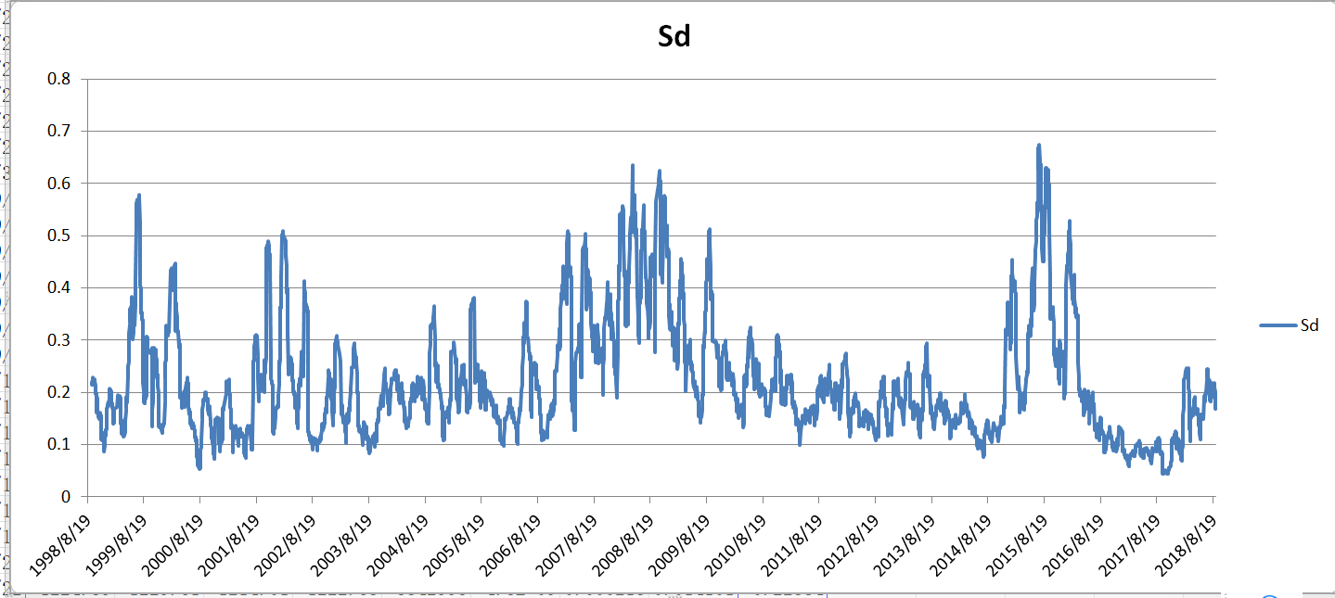

Trades analysis:

net pnl -798.1

breakdown:

||| PM_HILO # Trades: 2 Tot Q: -2.0 50.97,

Solution: increase base size, reduce time to wait (if last two orders within 60sec, wait 300 else 10)

Change name to index_pm_hilo.

||| PM_DEVI # Trades: 2 Tot Q: -1.0 25.49

Solution: trade at open level.

Change name to INDEX_PM_OPEN_DEVI.

||| PERC_MA # Trades: 1 Tot Q: 1.0 1.0

Solution: suspend this after hours.

||| FUT_PC_DEVI # Trades: 4 Tot Q: -1.0 -48.03,

Solution: trade at open level. Change to FUT_OPEN_DEVI, trade at FUTOPEN level only.

||| CHINA_HILO # Trades: 5 Tot Q: -1.0 -123.54,

* Change levels to conservative.

||| FUT_HILO # Trades: 5 Tot Q: -1.0 -173.54,

||| CLOSE_LIQ # Trades: 30 Tot Q: -12.0 -178.1 (something wrong with this one)

Solution: cancel all nonfilled orders after 5 min

||| OPEN_DEVI # Trades: 6 Tot Q: 2.0 -352.02, (size exposure is not good)

Solution: Trade at conservative level for all trades. Change name to index_devi.

1. All deviations trade conservatively at the benchline, limit loss on these trades (fut_open_devi, index_open_dev, pm_open_devi)
2. Futhilo, indexhilo, pmhilo(keep). Not paying PD (trade at better(index, fut))

Other:

1. No more overnight trades, liquidate at day’s end
2. Recently for 3 days, pm has been directional, whereas AM is not directional.

9.7

Friday

Market: Big rise followed by fall.

1. Not considered to be the ideal scenario (ideal scenario is considered to be big up/down

Problems

1. Problems of fill/cancel

net pnl -481.14 breakdown:

||| FUT_OPEN # Trades: 4 Tot Q: 4.0 119.0,

||| CLOSE_LIQ # Trades: 1 Tot Q: -1.0 23.5

||| FIRST_TICK # Trades: 1 Tot Q: 3.0 2.99, (change to IOC)

||| FUT_OPEN_DEVI # Trades: 6 Tot Q: 0.0 -27.54, (鸡肋 )

||| INDEX_OPEN_DEVI # Trades: 4 Tot Q: -1.0 -43.03, (鸡肋)

||| INDEX_HILO # Trades: 2 Tot Q: -1.0 -44.51, (鸡肋, limit only to morning)

||| INDEX_PM_OPEN_DEVI # Trades: 1 Tot Q: -1.0 -74.0 (buy not filled)

||| FUT_HILO # Trades: 4 Tot Q: -1.0 -193.03, (decommission)

||| INDEX_PM_HILO # Trades: 1 Tot Q: -3.0 -244.51 (buy not filled, more aggressive for first three orders)

Weekly review: Make sure delta pnl doesn’t impact too much next week.

This week changes

1. No more overnight delta
2. No more stock position
3. Calibrating trading strategies
4. Pmhilo works the best – but need to guarantee fills

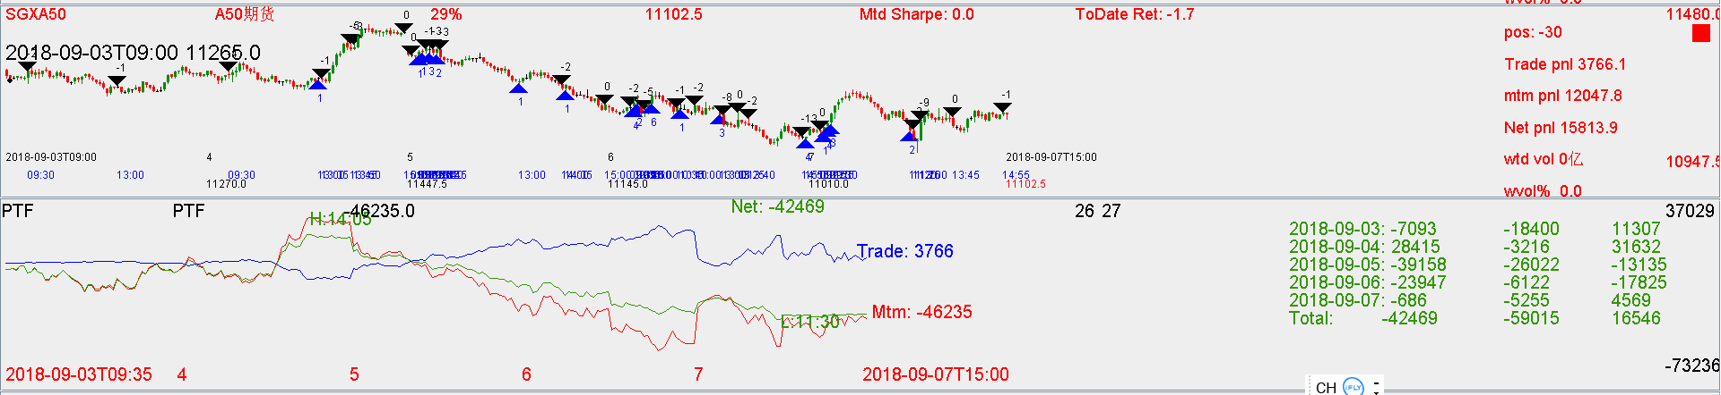

Mtm down -50k, next week focus on trading.